LAB TASKS LAB 7
Task 1:
#include <iostream>
using namespace std;

class DispatchRecord
{
public:
int DispatchID;
string CustomerName;
int DeliveryTime;
};

class CourierDispatch
{
public:
void inputRecords(DispatchRecord records[], int n)
{
for (int i = 0; i < n; i++) {
cout << "Enter Dispatch ID: ";
cin >> records[i].DispatchID;
cout << "Enter Customer Name: ";
cin >> records[i].CustomerName;
cout << "Enter Delivery Time (minutes): ";
cin >> records[i].DeliveryTime;
}
}

void displayRecords(DispatchRecord records[], int n)
{
for (int i = 0; i < n; i++)
{
cout << records[i].DispatchID << " " << records[i].CustomerName << " " << records[i].DeliveryTime << endl;
}
}

int partition(DispatchRecord records[], int low, int high)
{
int pivot = records[high].DeliveryTime;
int i = low - 1;
for (int j = low; j < high; j++)
{
if (records[j].DeliveryTime < pivot)
{
i++;
DispatchRecord temp = records[i];
records[i] = records[j];
records[j] = temp;
}
}
DispatchRecord temp = records[i + 1];
records[i + 1] = records[high];
records[high] = temp;
return i + 1;
}

void quickSort(DispatchRecord records[], int low, int high)
{
if (low < high)
{
int pi = partition(records, low, high);
quickSort(records, low, pi - 1);
quickSort(records, pi + 1, high);
}
}
};

int main()
{
int n;
cout << "Enter number of dispatch records: ";
cin >> n;
DispatchRecord records[100];
CourierDispatch cd;
cd.inputRecords(records, n);
cout << "\nBefore Sorting:\n";
cd.displayRecords(records, n);
cd.quickSort(records, 0, n - 1);
cout << "\nAfter Sorting (by Delivery Time):\n";
cd.displayRecords(records, n);
return 0;
}

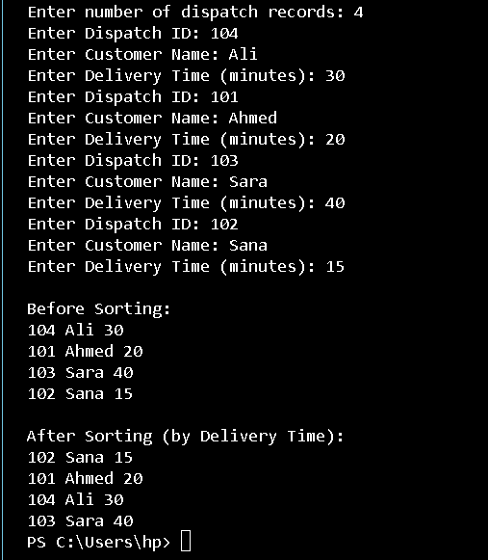
Task 2:
#include <iostream>
using namespace std;

int getMax(int arr[], int n)
{
int mx = arr[0];
for (int i = 1; i < n; i++)
{
if (arr[i] > mx)
{
mx = arr[i];
}
}
return mx;
}

void countSort(int arr[], int n, int exp)
{
int output[100];
int count[10] = {0};
for (int i = 0; i < n; i++)
{
count[(arr[i] / exp) % 10]++;
}
for (int i = 1; i < 10; i++)
{
count[i] += count[i - 1];
}
for (int i = n - 1; i >= 0; i--)
{
output[count[(arr[i] / exp) % 10] - 1] = arr[i];
count[(arr[i] / exp) % 10]--;
}
for (int i = 0; i < n; i++)
{
arr[i] = output[i];
}
cout << "\nAfter processing digit place " << exp << ": ";
for (int i = 0; i < n; i++)
{
cout << arr[i] << " ";
}
cout << endl;
}

void radixSort(int arr[], int n)
{
int m = getMax(arr, n);
for (int exp = 1; m / exp > 0; exp *= 10)
{
countSort(arr, n, exp);
}
}

int main()
{
int n;
cout << "Enter number of account numbers: ";
cin >> n;
int arr[100];
cout << "Enter " << n << " seven-digit account numbers:\n";
for (int i = 0; i < n; i++)
{
cin >> arr[i];
}

cout << "\nBefore Sorting:\n";
for (int i = 0; i < n; i++)
{
cout << arr[i] << " ";
}

cout << endl;
radixSort(arr, n);
cout << "\nAfter Sorting:\n";
for (int i = 0; i < n; i++)
{
cout << arr[i] << " ";
}

cout << endl;
return 0;
}

